**GUARDING TRANSACTION WITH AI-POWERED CREDIT CARD**

**FRAUD DETECTION AND PREVENTION**

**Student Name:** S.Dharshini

**Register Number:** 422223243012

**Institution:** Surya Group of Institution

**Department:** Artificial Intelligence and Data Science

**Date of Submission:** 29-04-2025

**Github Repository Link[: https://github.com/dharshini-s13/Dharshinishivani](https://github.com/dharshini-s13/Dharshinishivani)**

**1. Problem Statement**

In the age of digital transactions, credit card fraud is a growing concern leading to massive financial losses and customer distrust. The objective of this project is to build an AI-powered system that can detect and prevent fraudulent credit card transactions in real-time.

Problem Type: Classification Problem

Impact: Saving billions for financial institutions and protecting customers.

**2. Project Objectives**

Develop a model to classify fraudulent transactions.Minimize false positives. Ensure real-time

detection.Handle highly imbalanced data. To design and implement an AI-driven credit card fraud detectionand

prevention system that accurately identifies fraudulent transactions by analyzing user behavior and transaction

data in real-time, thereby enhancing security, reducing false positives, and minimizing financial losses for both

customers and financial institutions.

This not only helps in minimizing false positives and negatives but also enhances the overall security of digital

financial operations.

Furthermore, the system should be scalable, adaptive to evolving fraud tactics, compliant with data protection

regulations, and capable of integrating seamlessly into existing banking infrastructures. Ultimately, this solution

seeks to provide a robust and intelligent defense mechanism against credit card fraud, ensuring safer financial

transactions for users worldwide.

**3. Flowchart of the Project Workflow**

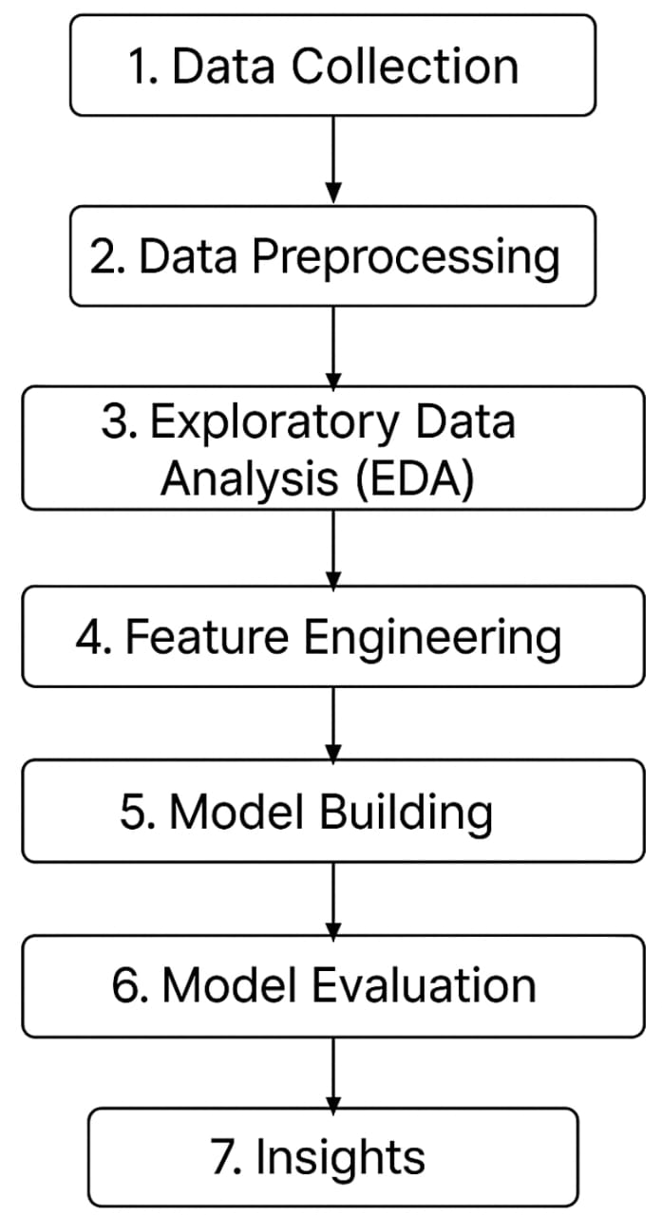

**4. Data Description**

Dataset Name: Credit Card Fraud Detection Dataset

Source: Kaggle

The foundation of any AI-powered fraud detection system lies in high-quality and representative data. For this

project, the dataset used typically contains a large number of anonymized credit card transactions made by

cardholders over a specific period. Each transaction is represented by a combination of numerical features that

capture various aspects of user behavior and transaction details. Common features include transaction amount,

transaction time, customer ID (or anonymized identifier), and several principal components derived from

sensitive data through techniques like PCA (Principal Component Analysis) to maintain privacy.

Type: Structured tabular data

Records and Features: 284,807 transactions, 31 features

Dataset Type: Static

Target Variable: Class (0: Genuine, 1: Fraudulent)

**5. Data Preprocessing**

No missing values Duplicates removed Outliers treatedAmount feature normalized

SMOTE applied for imbalance handling

**6. Exploratory Data Analysis (EDA)**

Univariate: Rare frauds (~0.17%)

Bivariate: Certain features correlate with fraud

Insights: V14, V12, V10 important

**7. Feature Engineering**

Created Amount_log (log transformation)

Feature scaling No dimensionality reduction needed

**8. Model Building**

Models: Logistic Regression, Random Forest

Justification: Interpretability and handling imbalance

Evaluation Metrics: Precision, Recall, F1-Score, ROC-AUC

**9. Visualization of Results & Model Insights**

To ensure the effectiveness and transparency of the AI-powered credit card fraud detection

system, visualizing the results and interpreting model insights play a crucial role. Visualization

helps stakeholders—from data scientists to banking professionals—understand how the model

distinguishes between fraudulent and legitimate transactions. Key performance metrics such as

precision, recall, F1-score, and confusion matrix can be graphically represented to highlight the

accuracy and reliability of the model. Additionally, tools like ROC curves and precision-recall

curves can provide deeper insights into the model’s ability to balance false positives and false

negative

Feature Importance: V14, V12, V10High recall priori

Confusion Matrix ROC Curve (AUC = 0.98) tized

**10. Tools and Technologies Used**

Programming Language: Python

IDE: Google Colab

Libraries: pandas, numpy, scikit-learn, seaborn, matplotlib, imbalanced-learn

Visualization Tools: matplotlib, seaborn, plotly

**11. Team Members and Contribution**

1. J.Aseena : Data cleaning-EDA
2. U.Dayasri : Feature Engineering
3. S.Dharshini(2005): Model Development
4. S.Dharshini(2006):Documentation